

MAKER PI PICO
Simplifying Raspberry Pi Pico for Beginner

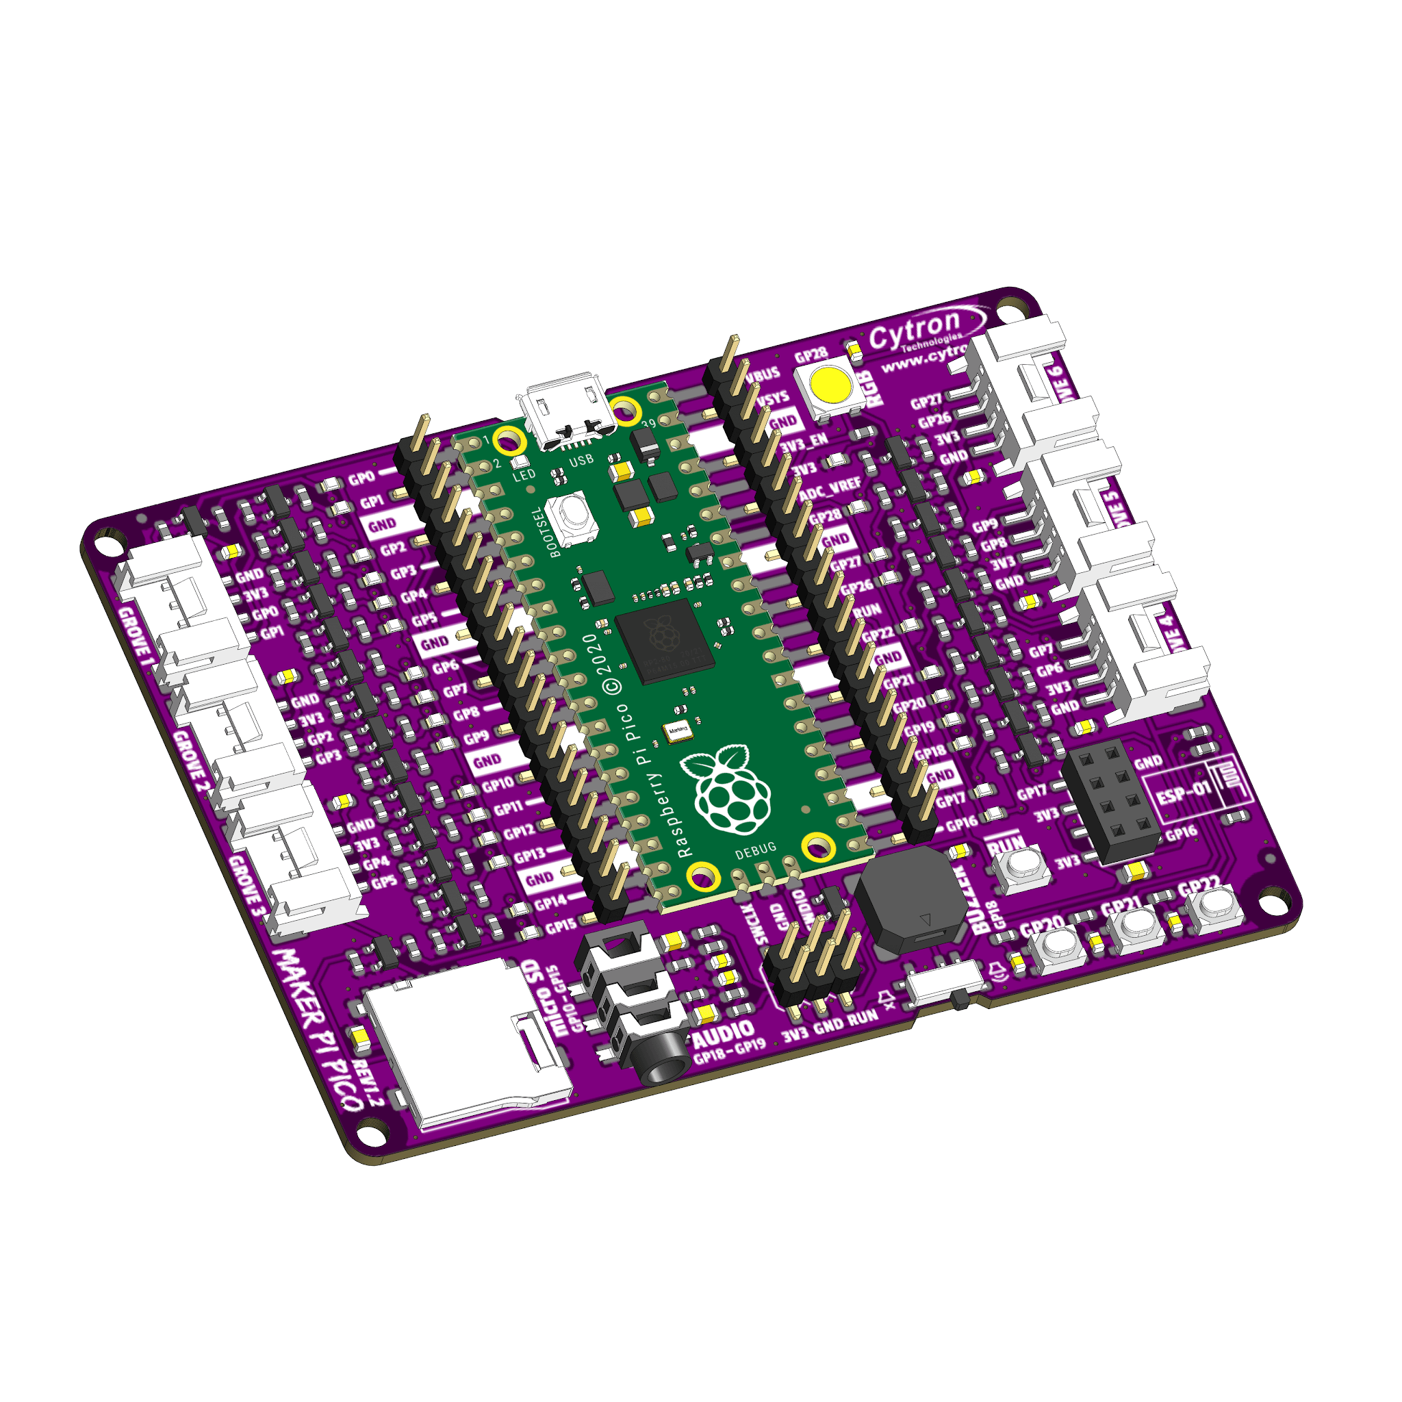
MAKER-PI-PICO

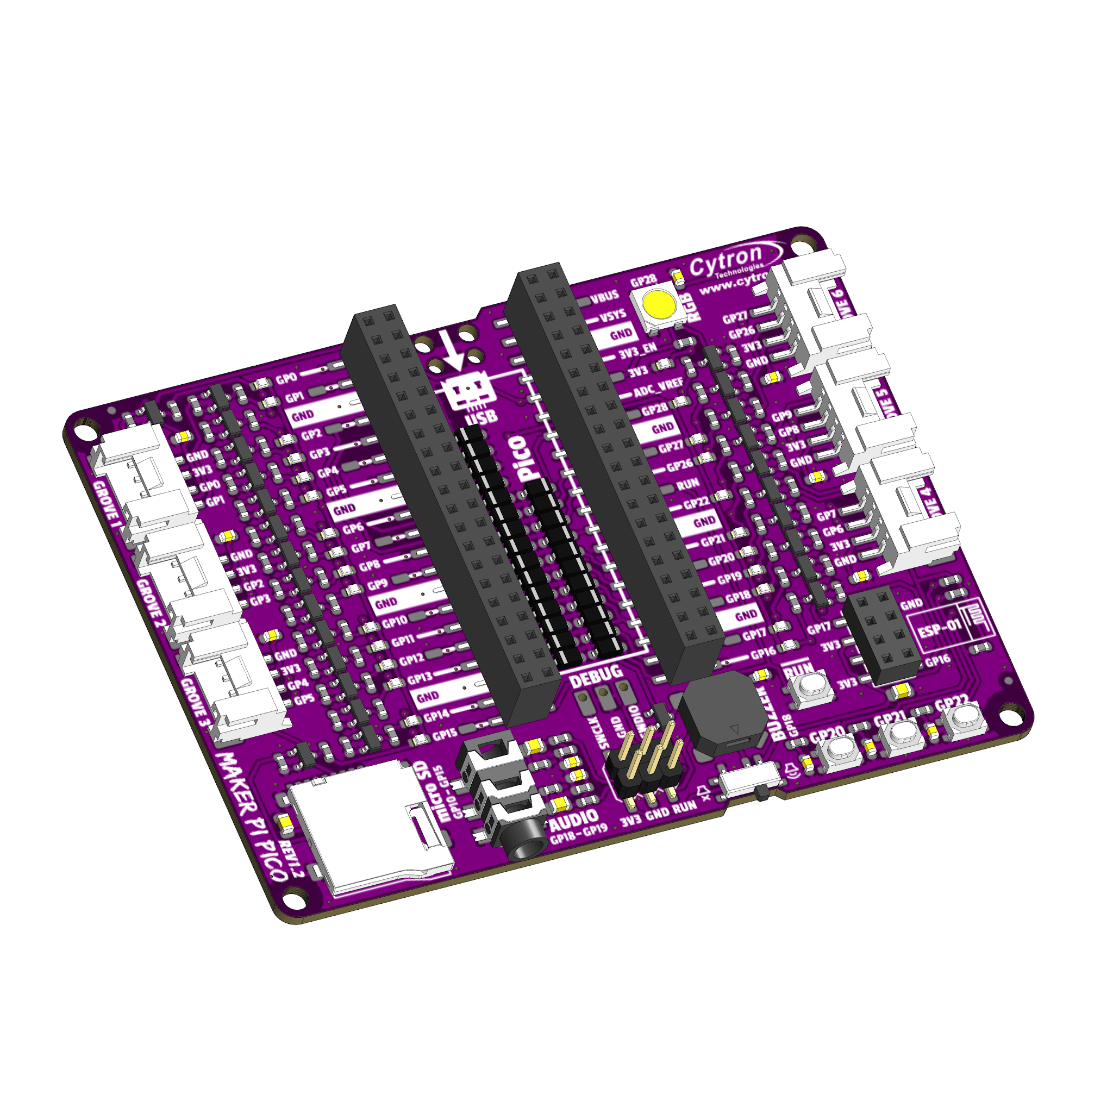
MAKER-PI-PICO-NB

Datasheet

Rev 1.2
March 2021

Information in this publication regarding device applications and the like is intended through suggestion only and may be superseded by updates. It is your responsibility to ensure that your application meets your specifications. No representation or warranty is given and no liability is assumed by Cytron Technologies Incorporated with respect to the accuracy or use of such information or infringement of patents or other intellectual property rights arising from such use or otherwise. Use of Cytron Technologies’s products as critical components in the life support system is not authorized except with express written approval by Cytron Technologies. No licenses are conveyed, implicitly or otherwise, under any intellectual property rights.

1. BOARD LAYOUT & FUNCTION

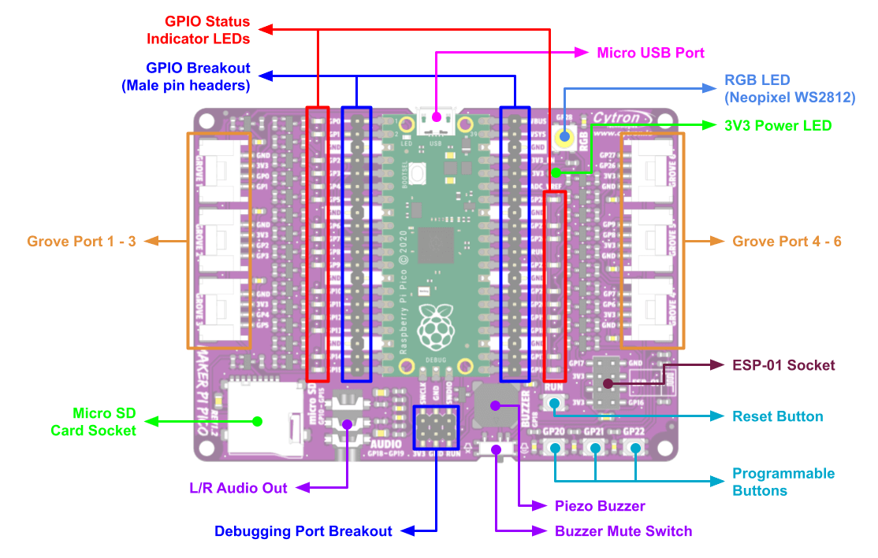
Figure 1: MAKER-PI-PICO Board Functions

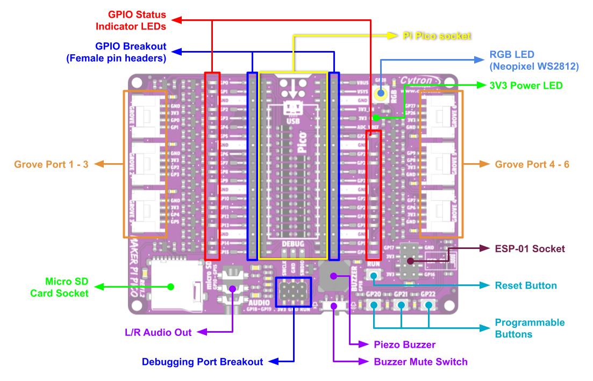
Figure 2: MAKER-PI-PICO-NB Board Functions

Function | Description
Micro USB Port  *MAKER-PI-PICO only | Used to power up the Maker Pi Pico and upload programs from PC.
3V3 Power LED | LED indicator for 3V3. Turn on when powered up.
GPIO LEDs | LED indicator for Raspberry Pi Pico GPIO.  Turn on when the GPIO state is high.
WS2812B RGB LED | User programmable WS2812B RGB LED. Connected to GP28.
GPIO Breakout | Breakout of the Raspberry Pi Pico GPIO pins.  * MAKER-PI-PICO = Male Pin Headers  * MAKER-PI-PICO-NB = Female Pin Headers
Debugging Port Breakout | Breakout of the Raspberry Pi Pico debugging port.
Reset Button | Press to reset the Raspberry Pi Pico.
Programmable Buttons | Connected to pin GP20, GP21 and GP22 respectively.  Accessible from the user program.  * Rev1.0.0 to 1.1.0 = To enable internal pull-up in software.  * Rev1.2.0 = Pulled-up permanently on hardware with debouncing capacitor.
Piezo Buzzer | Can be used to play tone or melody.  Connected to GP18.
Buzzer Mute Switch | Used to mute the piezo buzzer.
Audio Out | Non amplified audio output. Can be connected to an earphone or amplified speaker.  - Left Channel : GP18  - Right Channel : GP19
ESP-01 Socket | Socket for ESP-01 ESP8266 WiFi module.  Can be used to IoT-enable your project.
Micro SD Card Socket | Socket for micro SD Card.  Raspberry Pi Pico GPIO SD Card  SD Mode SPI Mode  GP10 GP11 GP12 GP13 GP14 GP15 CLK CMD DAT0 DAT1 DAT2 CD/DAT3 SCK SDI SDO X X CSn  * Unused pins must be configured as internal pull-ups.
Pi Pico Socket  *MAKER-PI-PICO-NB only | Socket for Raspberry Pi Pico.  Can be used with Raspberry Pi Pico with Pre-soldered Headers.

Table 1: MAKER-PI-PICO & MAKER-PI-PICO-NB Board Functions

2. RASPBERRY PI PICO PINOUT DIAGRAM

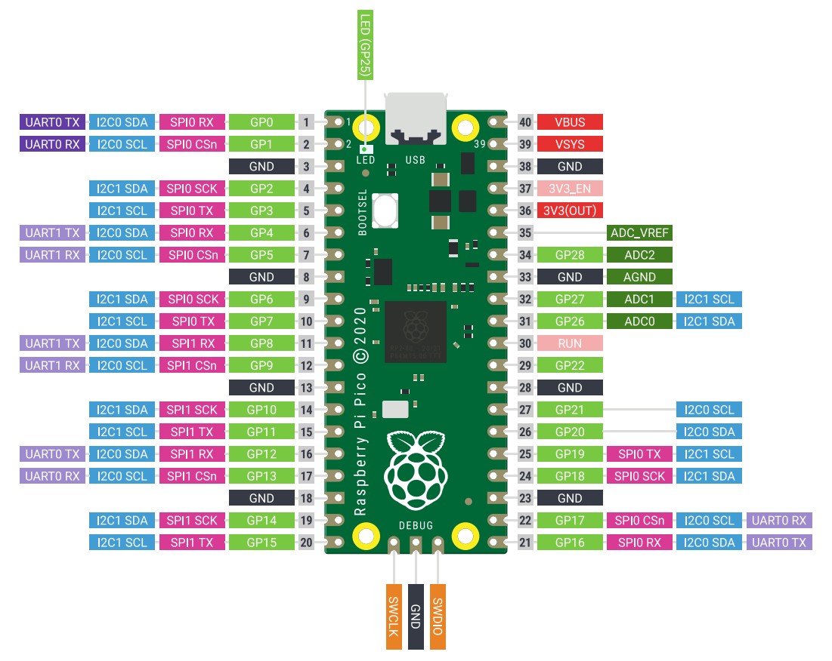
Figure 3: Raspberry Pi Pico Pinout Diagram

3. SPECIFICATIONS

No | Parameters |  | Min | Max | Unit
1 | Power Input Voltage (USB) |  | 4.5 | 5.5 | VDC
2 | Digital Input Voltage | Low Level | -0.3 | 0.8 | V
 |  | High Level | 2.0 | 3.6 | V
3 | Digital Output Voltage | Low Level | 0 | 0.5 | V
 |  | High Level | 2.62 | 3.3 | V
4 | Analog Input Voltage |  | 0 | 3.3 | V
5 | Operating Temperature |  | -20 | 85 | ℃
Table 2: MAKER-PI-PICO Absolute Maximum Ratings

4. DIMENSION
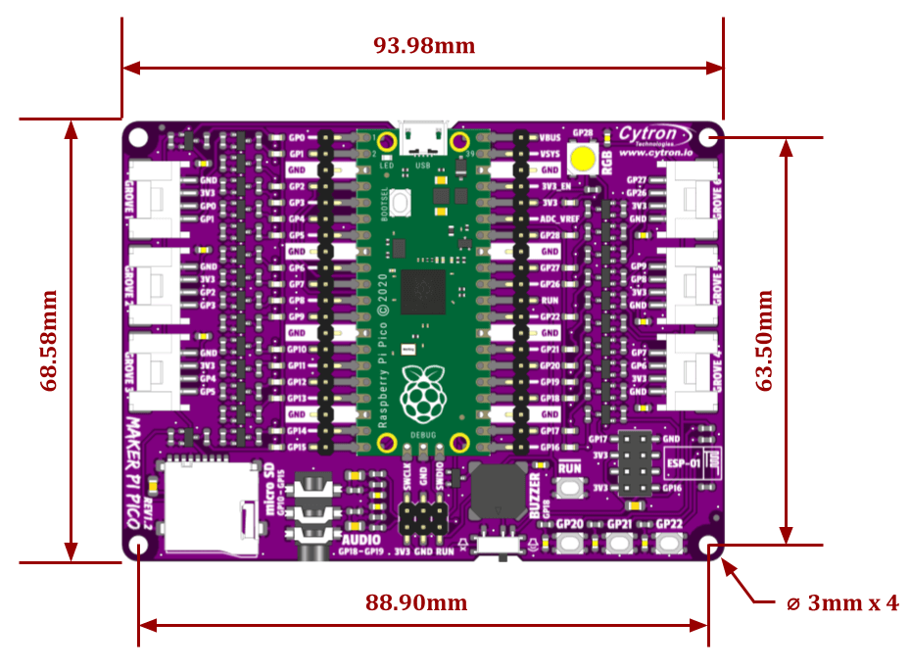
Figure 4: MAKER-PI-PICO Dimension

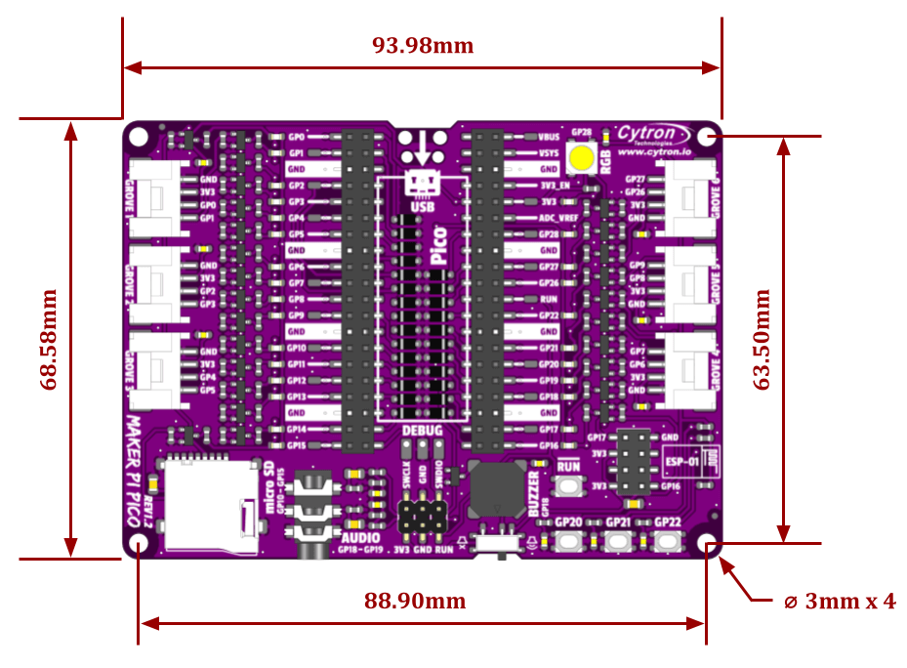
Figure 5: MAKER-PI-PICO Dimension

Prepared by:

Cytron Technologies Sdn Bhd
www.cytron.io
No. 1, Lorong Industri Impian 1,
Taman Industri Impian,
14000 Bukit Mertajam,
Penang, Malaysia.

Tel: +604 - 548 0668
Fax: +604 - 548 0669

Email:
support@cytron.io
sales@cytron.io

